Informed Search Heuristics

David Graves
Colorado State University Global
CSC510
Dr. Bingdong Li
October 1, 2025

Shortest route: A* Search
There are many real-world scenarios and problems where we can leverage informed search methods to discover optimal solutions via computer programming. Quality Heuristic search functions can be written in any number of different languages to accomplish this task, with Python being a great option due to its ease of use and robust existing libraries. One such library/resource is ‘simpleai’ that was designed and developed within the last 10 years by the simpleai team. Not only does this library have good functionality built-in, but great background and samples for usage like tic tac toe, language classification, and more. (Fisanotti & Berrotaran & Carrascosa, 2023) I will use much of what I learned from this resource to develop and execute an interactive Python script using a heuristic solution to solve a shortest route problem. For this case I chose an 8-city map (Image 1) which has 2,530 possible solutions, ((n-1)!)/2) and decided to use an A* search method to calculate the single shortest route from a starting city to a final one. This method makes sense when an admissible heuristic is used and should guarantee the shortest path. Since I am looking for the shortest path between cities, I opted to import latitude and longitude and calculate their straight-line distance to use as an admissible heuristic because it should not overestimate the minimal cost between cities. This is also complete because if a solution exists, which should be here, it will find it. The evaluation function is not explicitly written in the code but is embedded in the ‘astar’ function that was imported from the ‘simpleai’ library. This algorithmic approach is not necessarily efficient because it stores all generated paths in memory, however for this size of graph it works. If this was a big map then I’d want a different approach which highlights one of the key disadvantages of this informed search approach for this use case. It’s not suitable for complex and dense graphs and it’s performance hinges on the quality of the heuristic. This approach has its advantages too though, including the fact that it found the optimal path in all cases as shown in (Image 3). It was able to do this because I employed meaningful heuristics on a small enough graph that was complete and finite.
Directions for Program Execution
I’ve included the file ‘better_city_astar.py’ which can be executed by running the program and keying in both start and end cities from the list of available options.
Image 1
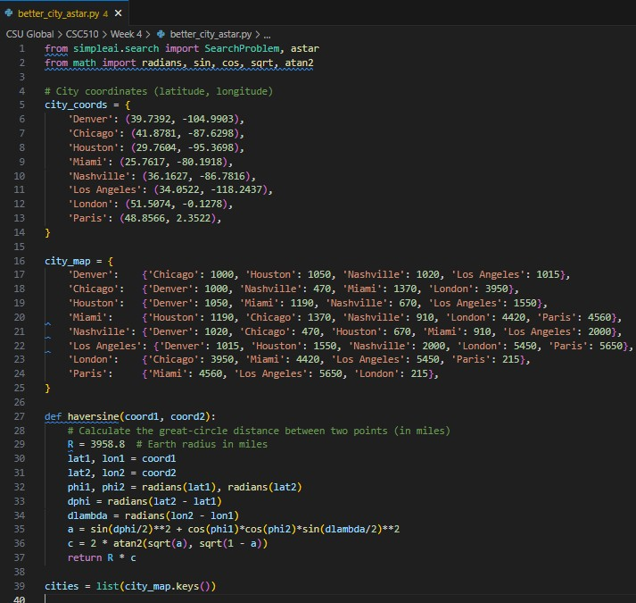
Image 2
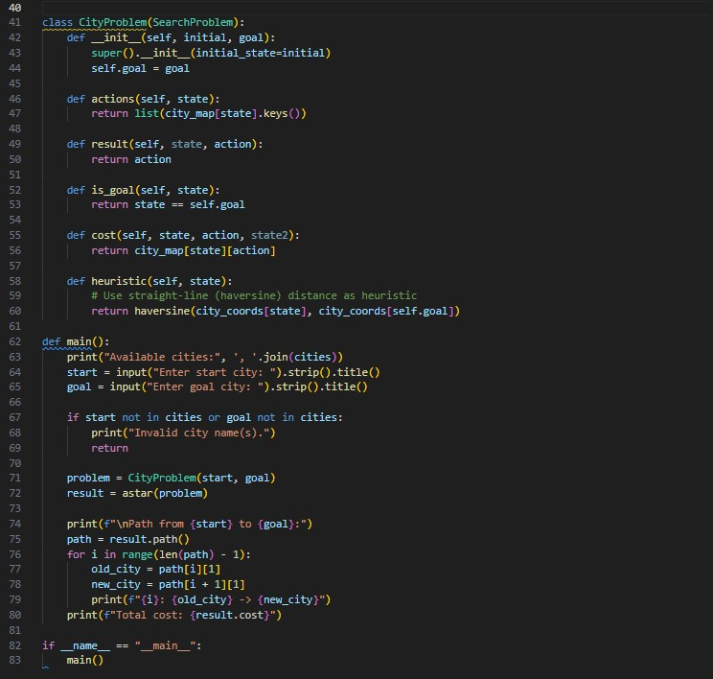
Image 3
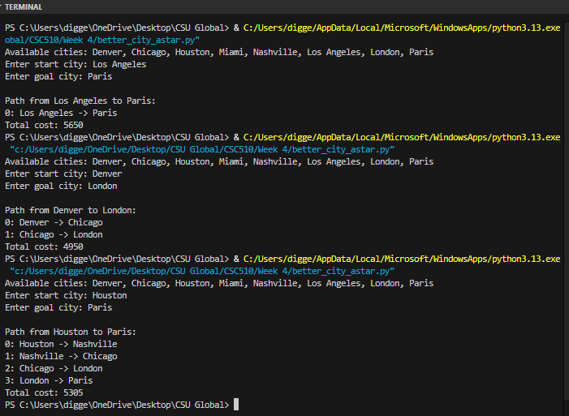
Reference
Fisanotti, Juan Pedro & Berrotaran, Gonzalo Garcia & Carrascosa, Rafael. (2023, Nov 5).
Github.com. Repositories-simpleai-samples.
simpleai/samples/machine_learning at master · simpleai-team/simpleai · GitHub

